**Property Indication**

1. **Property Information:**

|  |  |
| --- | --- |
| **Property: Address:** | #A-132, St. Maha A, Phum Vimean Trung, S/k. Krang Thnug, Khan Sen Sok, Phnom Penh. |
| **Property Type:** | A parcel of land accommodating an under-constructed a storey flat (0% completed). |
| **Front Road:** | 10m |
| **Land Size:** | 102.50 sqm (25m x 4.1m) |
| **Building Size:** | 57.40 sqm (14m x 4.1m) |
| **Title Deed No:** | Will have hard tittle |
| **SPA:** | USD52,430.00 |

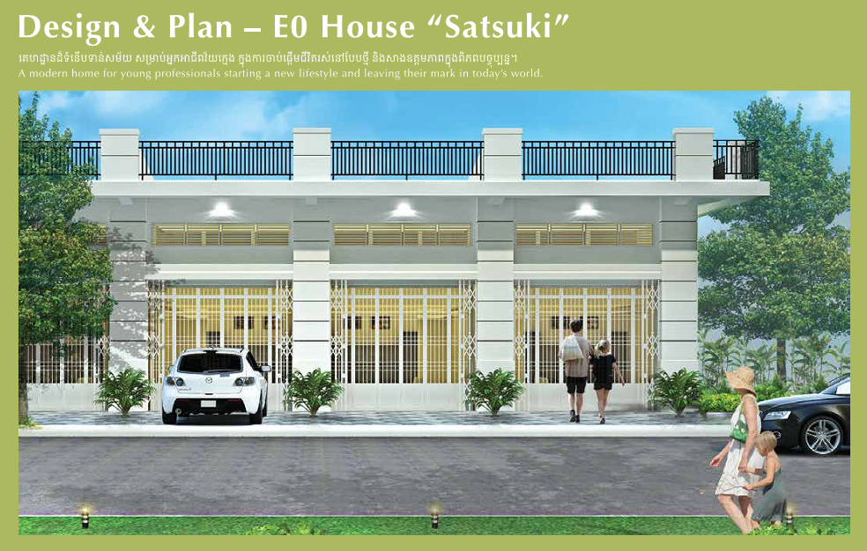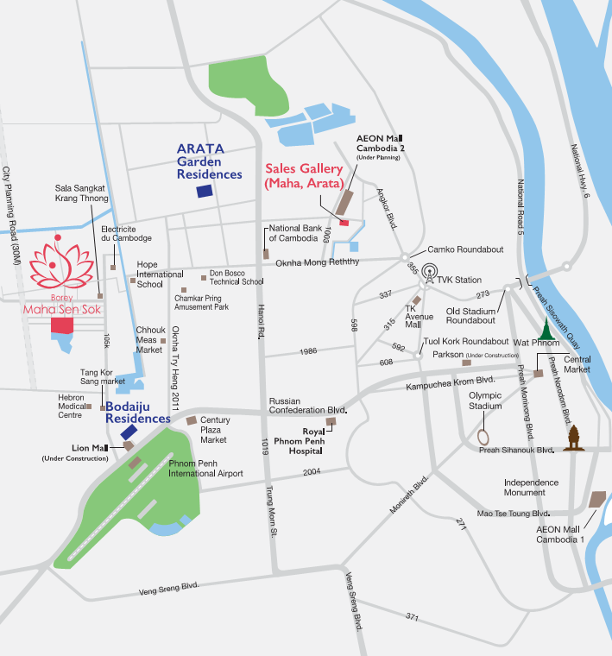

Subject Property

